I hope you have had a great year and are looking forward to 2015! In order to plan for the year ahead, it is important to begin with reviewing the year that has just passed. Carve out some time in your schedule to answer these questions. You can do it all at once or break it up into short amounts of time over several sittings. The important thing is that you make the time and space to begin to consciously create the life you want to have.
A Year in Review:
- What are my top 10 highlights of this year?

- How am I different now than I was in January 2014?

- What do I want to celebrate about 2014?

- What do I need to let go of/forgive myself for that's hanging over me from the last 12 months?

- What situations, hurts, anger and/or relationships do I need to let go of/forgive to make room for what I want in the new year?

- What are the 5 biggest lessons I learned this year?

- How can I apply those lessons in the upcoming year?
Planning for the New Year

- How do I want to feel? List core desired feelings.

- How will I know I am feeling those feelings? What will I be doing, saying, thinking and feeling when I am feeling those feeling than I am now?

- In order to feel those feeling as often as possible, what do I need to add, change, or eliminate in my daily routine this year?

- What am I doing that thrills me and I absolutely love?

- What am I doing that is draining the life out of me?

- What am I tolerating in my life?

- What are my major values and purposes for the next phase of my life?

- How can I make more room in my schedule to do more of what brings me the most fulfillment and gratification?

- What is something I would do this year if I weren't worried about what other people thought of me?

- How can I use my greatest talents to benefit myself and many others in the year ahead?

- Looking back at your answers, what is the theme for 2015?

- Finish the following statement: “I want to remember 2015 as the year I . . . . . “

If you struggled with answering these questions or you want support creating your life the way you want it to be, I am happy to talk with you about how I can help.

Melanie@MelanieYost.com

540-907-4146

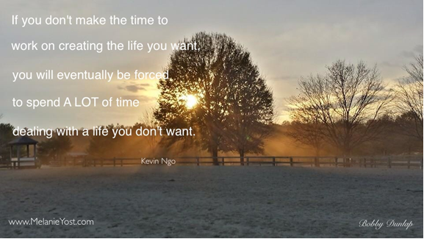

Happy New Year!!

